**大连理工大学实验报告**

学院（系）： 电子信息与电气工程学部 专业： 电子信息工程 班级： 电信1801

姓 名： 杨题鸣 学号： 201883016 组： ___

实验时间： 2020/5/31 实验室： 实验台：

指导教师签字： 成绩：

**实验二 系统分析**

一、实验题目和结果

**实验题目设计：调制解调系统**

**任务1:**

代码如下：

function varargout = main(varargin)

% MAIN MATLAB code for main.fig

% MAIN, by itself, creates a new MAIN or raises the existing

% singleton*.

%

% H = MAIN returns the handle to a new MAIN or the handle to

% the existing singleton*.

%

% MAIN('CALLBACK',hObject,eventData,handles,...) calls the local

% function named CALLBACK in MAIN.M with the given input arguments.

%

% MAIN('Property','Value',...) creates a new MAIN or raises the

% existing singleton*. Starting from the left, property value pairs are

% applied to the GUI before main_OpeningFcn gets called. An

% unrecognized property name or invalid value makes property application

% stop. All inputs are passed to main_OpeningFcn via varargin.

%

% *See GUI Options on GUIDE's Tools menu. Choose "GUI allows only one

% instance to run (singleton)".

%

% See also: GUIDE, GUIDATA, GUIHANDLES

% Edit the above text to modify the response to help main

% Last Modified by GUIDE v2.5 02-Jun-2020 16:39:16

% Begin initialization code - DO NOT EDIT

gui_Singleton = 1;

gui_State = struct('gui_Name', mfilename, ...

'gui_Singleton', gui_Singleton, ...

'gui_OpeningFcn', @main_OpeningFcn, ...

'gui_OutputFcn', @main_OutputFcn, ...

'gui_LayoutFcn', [] , ...

'gui_Callback', []);

if nargin && ischar(varargin{1})

gui_State.gui_Callback = str2func(varargin{1});

end

if nargout

[varargout{1:nargout}] = gui_mainfcn(gui_State, varargin{:});

else

gui_mainfcn(gui_State, varargin{:});

end

% End initialization code - DO NOT EDIT

% --- Executes just before main is made visible.

function main_OpeningFcn(hObject, eventdata, handles, varargin)

% This function has no output args, see OutputFcn.

% hObject handle to figure

% eventdata reserved - to be defined in a future version of MATLAB

% handles structure with handles and user data (see GUIDATA)

% varargin command line arguments to main (see VARARGIN)

% Choose default command line output for main

handles.output = hObject;

% Update handles structure

guidata(hObject, handles);

% UIWAIT makes main wait for user response (see UIRESUME)

% uiwait(handles.figure1);

% --- Outputs from this function are returned to the command line.

function varargout = main_OutputFcn(hObject, eventdata, handles)

% varargout cell array for returning output args (see VARARGOUT);

% hObject handle to figure

% eventdata reserved - to be defined in a future version of MATLAB

% handles structure with handles and user data (see GUIDATA)

% Get default command line output from handles structure

varargout{1} = handles.output;

% --- Executes on button press in pushbutton3.

function pushbutton3_Callback(hObject, eventdata, handles)

% hObject handle to pushbutton3 (see GCBO)

% eventdata reserved - to be defined in a future version of MATLAB

% handles structure with handles and user data (see GUIDATA)

global y1;

global y2;

global Yi;

**%调制过程**

fs=2000;

t= -0.1:1/fs:0.1;

N=length(t);

Yi=y1.*y2.*y2;

Yii=y1.*y2;

Yw = fft(Yii);

f=(0:N-1)*fs/length(t) - fs/2;

plot(handles.axes5,t,Yii);

set(handles.axes5,'YLim');

title(handles.axes5,'调制时域波形');

plot(handles.axes6,f,fftshift(abs(Yw)));

title(handles.axes6,'调制幅度谱');

guidata(hObject, handles);

% --- Executes on button press in pushbutton5.

function pushbutton5_Callback(hObject, eventdata, handles)

% hObject handle to pushbutton5 (see GCBO)

% eventdata reserved - to be defined in a future version of MATLAB

% handles structure with handles and user data (see GUIDATA)

global Yi;

global omega1;

global omega2;

**%解调过程**

fs=2000;

t= -0.1:1/fs:0.1;

N=length(t);

f=(0:N-1)*fs/length(t) - fs/2;

fL=omega1*1.05;fH=omega2*0.95;

Wp=fL/(fs/2); Ws=fH/(fs/2);

Rp=3; Rs=20;

[N,Wn]= buttord(Wp,Ws,Rp,Rs) ;

[B,A]=butter(N,Wn,'low');

m0=filtfilt(B,A,Yi); **%m0是滤波器滤波后的信号**

Yk = fft(m0);

plot(handles.axes5,t,m0);

set(handles.axes5,'YLim');

title(handles.axes5,'解调时域波形');

plot(handles.axes6,f,fftshift(abs(Yk)));

title(handles.axes6,'解调幅度谱');

guidata(hObject, handles);

function edit2_Callback(hObject, eventdata, handles)

% hObject handle to edit2 (see GCBO)

% eventdata reserved - to be defined in a future version of MATLAB

% handles structure with handles and user data (see GUIDATA)

% Hints: get(hObject,'String') returns contents of edit2 as text

% str2double(get(hObject,'String')) returns contents of edit2 as a double

% --- Executes during object creation, after setting all properties.

function edit2_CreateFcn(hObject, eventdata, handles)

% hObject handle to edit2 (see GCBO)

% eventdata reserved - to be defined in a future version of MATLAB

% handles empty - handles not created until after all CreateFcns called

% Hint: edit controls usually have a white background on Windows.

% See ISPC and COMPUTER.

if ispc && isequal(get(hObject,'BackgroundColor'), get(0,'defaultUicontrolBackgroundColor'))

set(hObject,'BackgroundColor','white');

end

% --- Executes on button press in pushbutton2.

function pushbutton2_Callback(hObject, eventdata, handles)

% hObject handle to pushbutton2 (see GCBO)

% eventdata reserved - to be defined in a future version of MATLAB

% handles structure with handles and user data (see GUIDATA)

**%载波信号**

global y2;

global omega2;

fs=2000;

omega2 = str2num(get(handles.edit2,'String'));

A2 = str2num(get(handles.edit5,'String'));

t= -0.1:1/fs:0.1;

y2=sin(2*pi*omega2*t);

fy = fft(y2);

N=length(t);

f=(0:N-1)*fs/length(t) - fs/2;

plot(handles.axes4,t,y2);

set(handles.axes4,'YLim');

title(handles.axes4,'时域波形');

plot(handles.axes3,f,fftshift(abs(fy)));

title(handles.axes3,'幅度谱');

guidata(hObject, handles);

function edit1_Callback(hObject, eventdata, handles)

% hObject handle to edit1 (see GCBO)

% eventdata reserved - to be defined in a future version of MATLAB

% handles structure with handles and user data (see GUIDATA)

% Hints: get(hObject,'String') returns contents of edit1 as text

% str2double(get(hObject,'String')) returns contents of edit1 as a double

% --- Executes during object creation, after setting all properties.

function edit1_CreateFcn(hObject, eventdata, handles)

% hObject handle to edit1 (see GCBO)

% eventdata reserved - to be defined in a future version of MATLAB

% handles empty - handles not created until after all CreateFcns called

% Hint: edit controls usually have a white background on Windows.

% See ISPC and COMPUTER.

if ispc && isequal(get(hObject,'BackgroundColor'), get(0,'defaultUicontrolBackgroundColor'))

set(hObject,'BackgroundColor','white');

end

% --- Executes on button press in pushbutton1.

function pushbutton1_Callback(hObject, eventdata, handles)

% hObject handle to pushbutton1 (see GCBO)

% eventdata reserved - to be defined in a future version of MATLAB

% handles structure with handles and user data (see GUIDATA)

**%调制信号**

global y1;

global omega1;

fs=2000;

omega1 = str2num(get(handles.edit1,'String'));

A1 = str2num(get(handles.edit4,'String'));

t= -0.1:1/fs:0.1;

y1=A1*sin(2*pi*omega1*t);

fy = fft(y1);

N=length(t);

f=(0:N-1)*fs/length(t) - fs/2;

plot(handles.axes2,t,y1);

set(handles.axes2,'YLim');

title(handles.axes2,'时域波形');

plot(handles.axes1,f,fftshift(abs(fy)));

title(handles.axes1,'幅度谱');

guidata(hObject, handles);

function edit5_Callback(hObject, eventdata, handles)

% hObject handle to edit5 (see GCBO)

% eventdata reserved - to be defined in a future version of MATLAB

% handles structure with handles and user data (see GUIDATA)

% Hints: get(hObject,'String') returns contents of edit5 as text

% str2double(get(hObject,'String')) returns contents of edit5 as a double

% --- Executes during object creation, after setting all properties.

function edit5_CreateFcn(hObject, eventdata, handles)

% hObject handle to edit5 (see GCBO)

% eventdata reserved - to be defined in a future version of MATLAB

% handles empty - handles not created until after all CreateFcns called

% Hint: edit controls usually have a white background on Windows.

% See ISPC and COMPUTER.

if ispc && isequal(get(hObject,'BackgroundColor'), get(0,'defaultUicontrolBackgroundColor'))

set(hObject,'BackgroundColor','white');

end

function edit4_Callback(hObject, eventdata, handles)

% hObject handle to edit4 (see GCBO)

% eventdata reserved - to be defined in a future version of MATLAB

% handles structure with handles and user data (see GUIDATA)

% Hints: get(hObject,'String') returns contents of edit4 as text

% str2double(get(hObject,'String')) returns contents of edit4 as a double

% --- Executes during object creation, after setting all properties.

function edit4_CreateFcn(hObject, eventdata, handles)

% hObject handle to edit4 (see GCBO)

% eventdata reserved - to be defined in a future version of MATLAB

% handles empty - handles not created until after all CreateFcns called

% Hint: edit controls usually have a white background on Windows.

% See ISPC and COMPUTER.

if ispc && isequal(get(hObject,'BackgroundColor'), get(0,'defaultUicontrolBackgroundColor'))

set(hObject,'BackgroundColor','white');

end

**结果：**

**调制信号与载波信号以及调制结果**

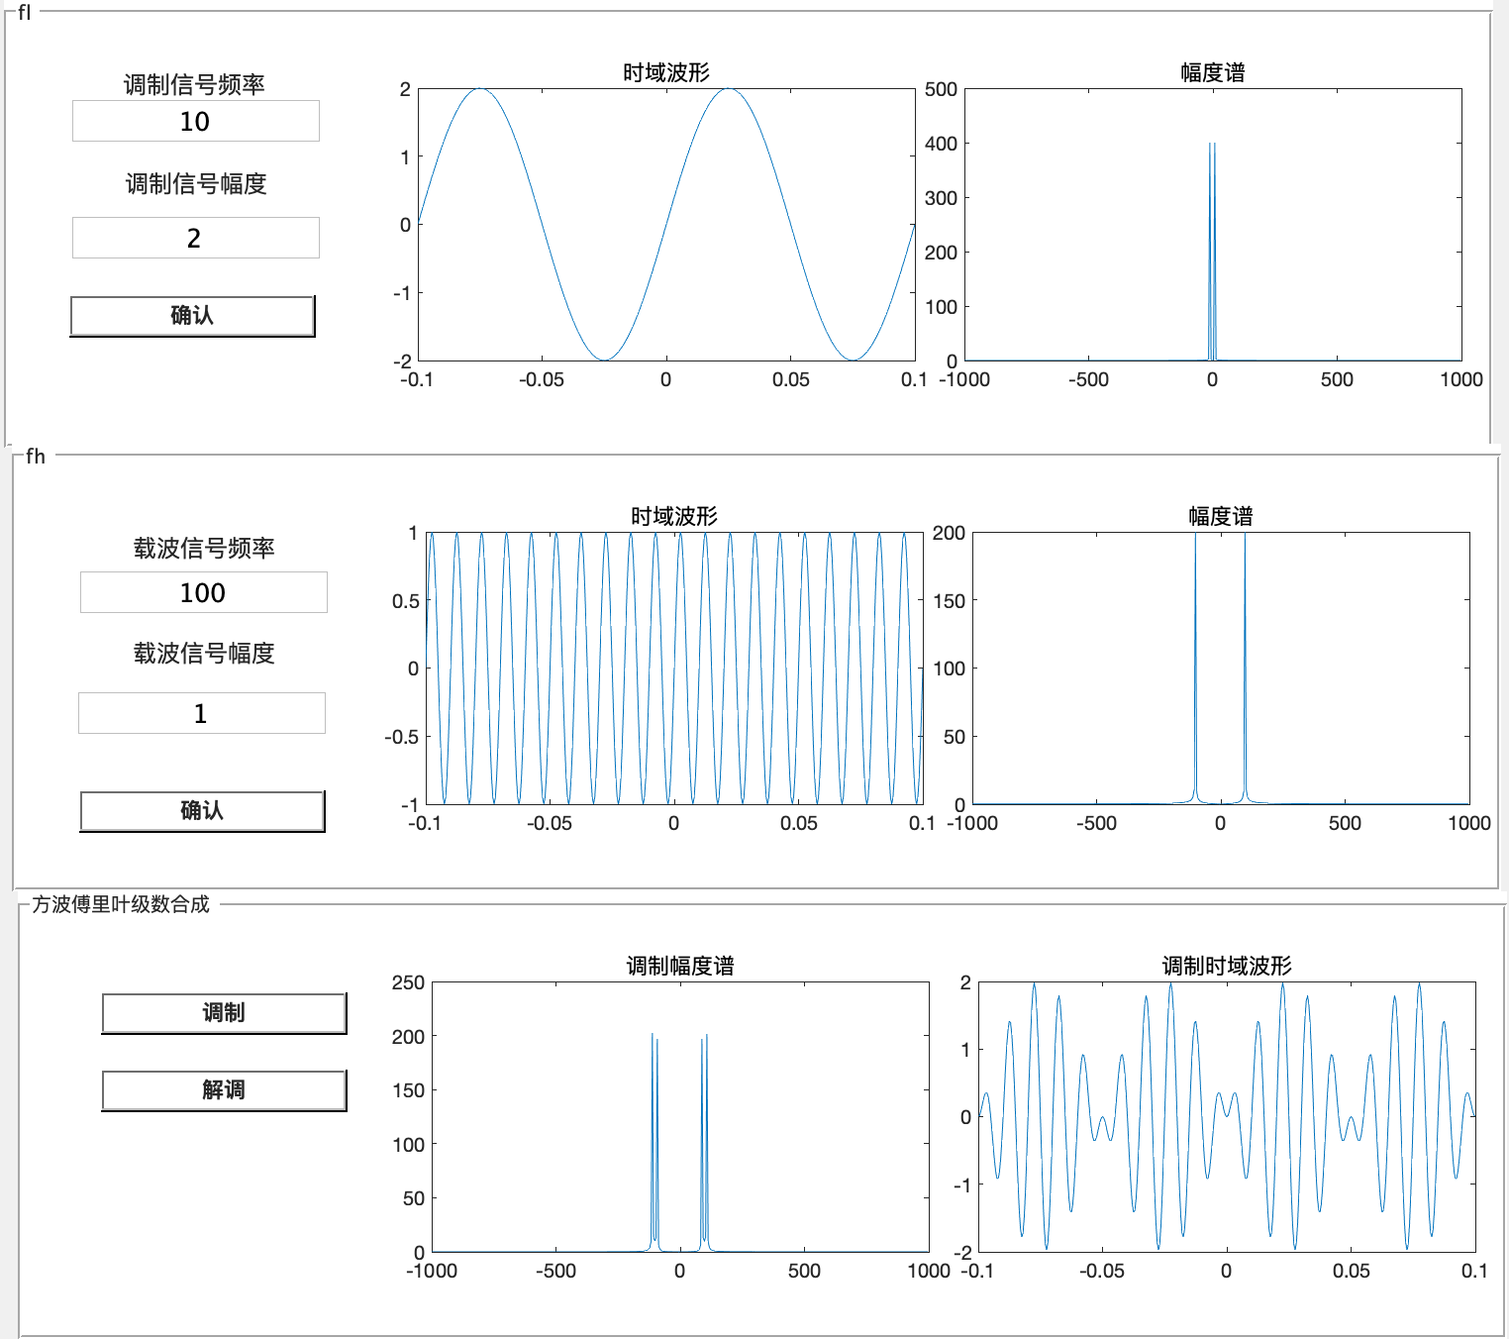

**调制信号与载波信号以及解调结果**

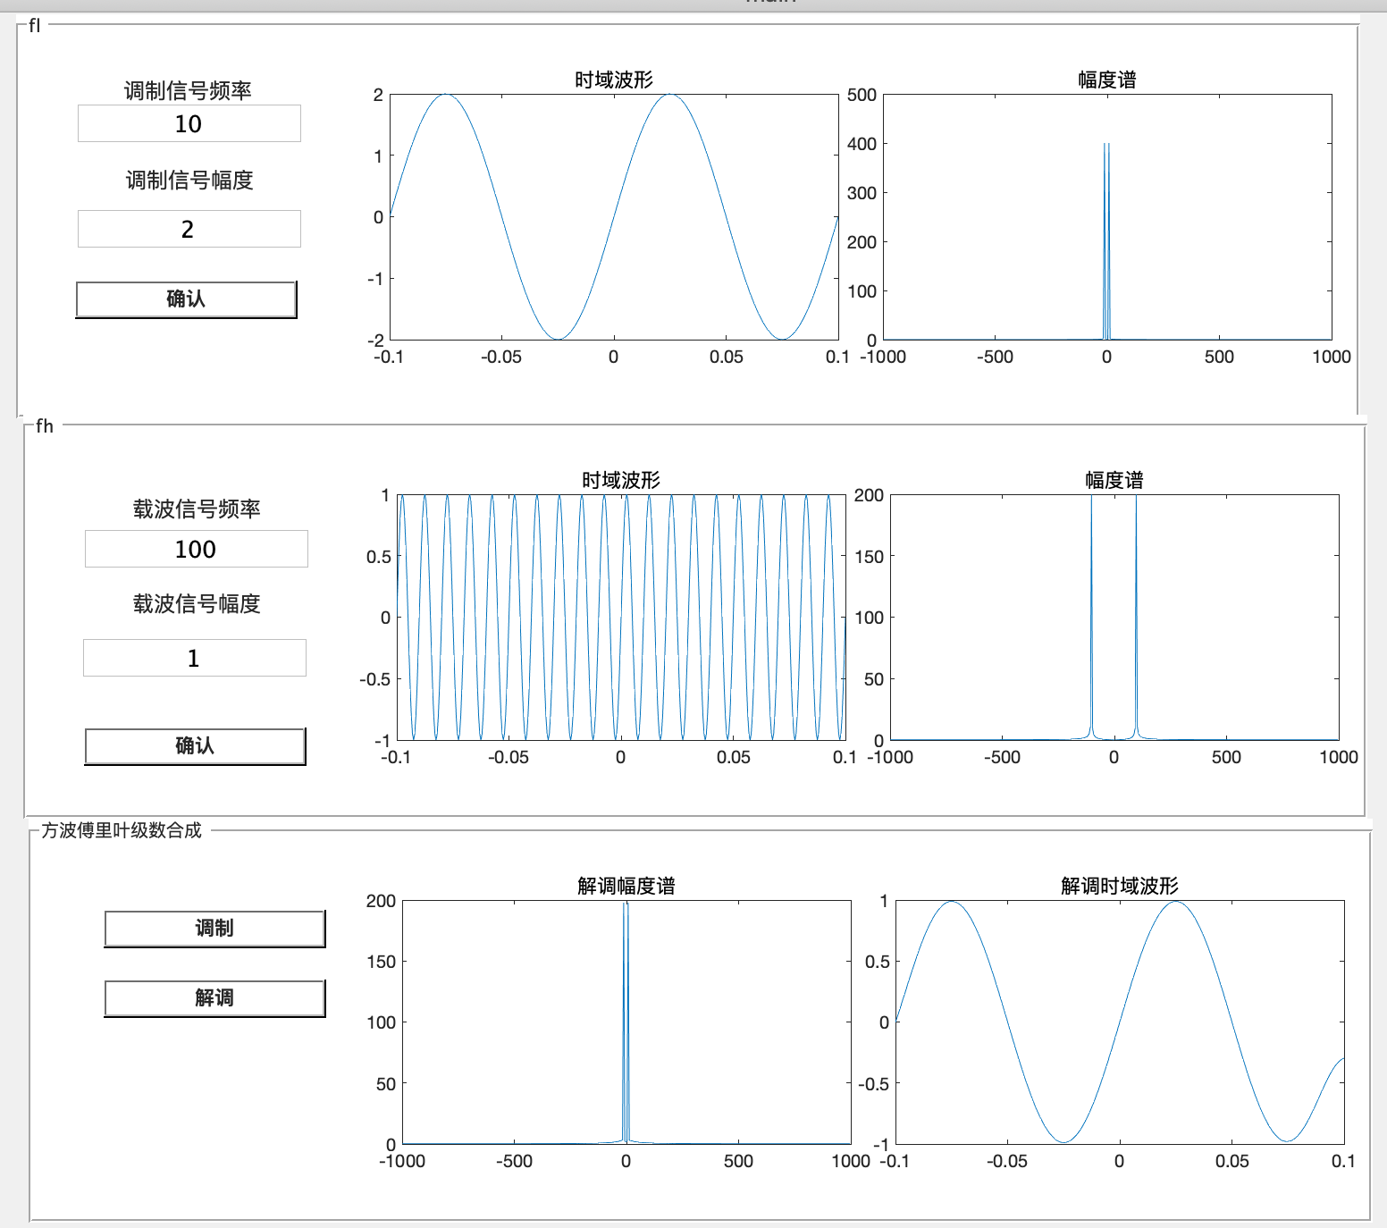

**任务2：**

**界面：**

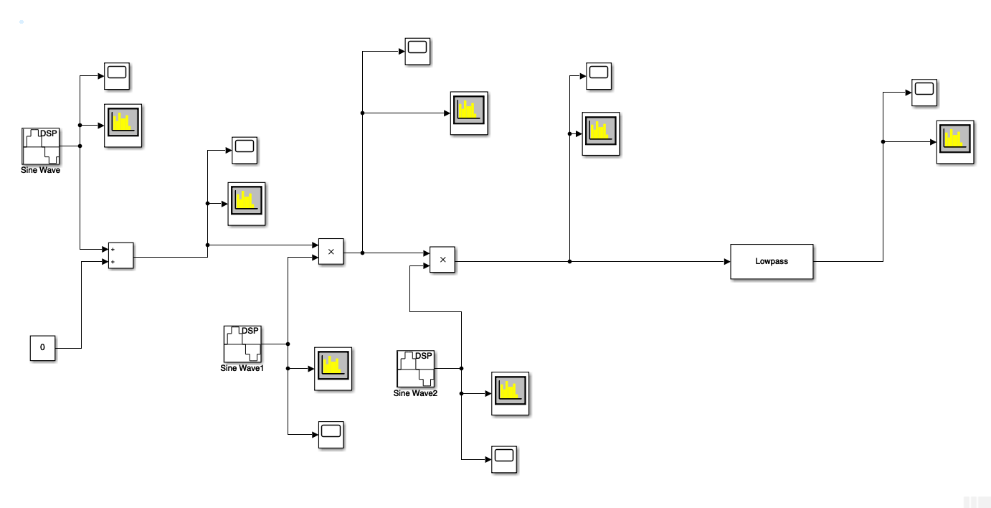

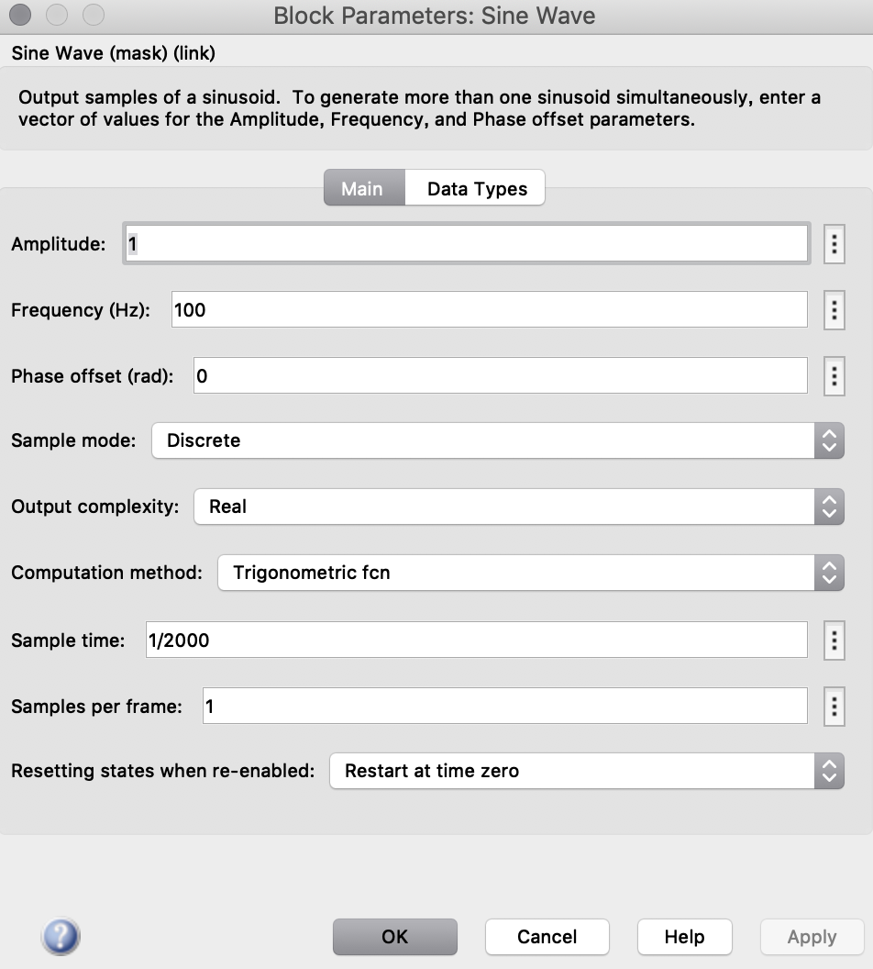 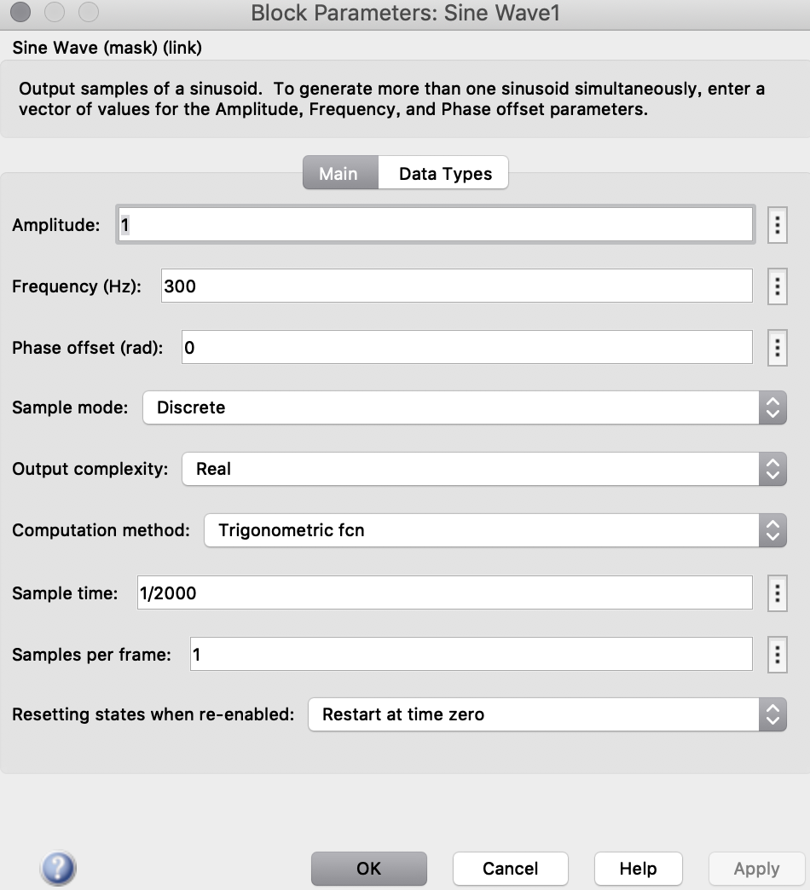

调制信号 载波信号

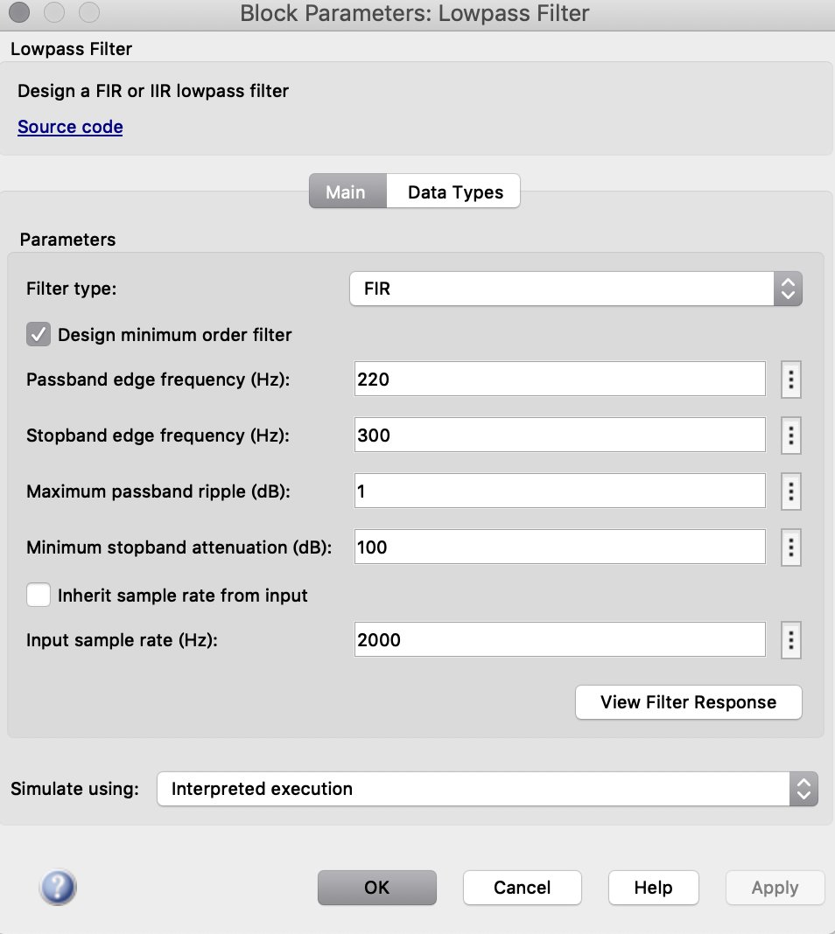

滤波器的参数

调制信号：

载波信号：

调制后的信号：

解调后的信号：

二、实验总结

本次实验当中，学会了在matlab当中函数与函数之间如何参数传递，我采用的方式是用global函数就可以进行参数在函数之间进行传递。本次实验有增加了simulink的使用，还是很快适应了simulink的用法，在一定程度观察调制解调比起自己敲代码更为方便。

这一次最难的我认为是，在低通滤波器上面，如何找到一个合适的参数，真的比较困难，有时候某种参数在某一个频率上比较适合，能够较好的调制解调，但是有时候改变频率后，发现结果又会有变化。

还有一个比较难的便是，调制信号和载波信号相乘的地方，我出现了一些问题，我一开始做的时候是y=y1.*y2。但是结果却总是错误的。不知道原因是什么，后面改成了y=y1.*y2.*y2;结果就好了。错误的原因，就是我不能很好的理解调制解调，以及对信号与系统的知识忘记得比较多了，所以造成了许许多多的问题。